Type-C Multi-Function

Compact Docking Station
4K HMDI + Gigabit LAN + 2 Port USB3.0 + PD Charge Port

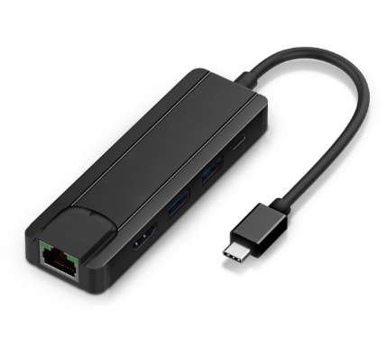
C-TC-DK-HDMI

Descrption:
Ultra-compact, the must-have USB-C docking station for your Type-C MacBook ProTM, ChromeBookTM, DellTM XPS and other notebook or desktop computers with the next generation Type-C ports.
Instantly connect an external 4K HDMI monitor, TV or projector. Connect to your wired Gigabit Ethernet LAN, USB keyboards, mice and external USB storage devices, simultaneously without any loss of speed or performance. Stylish in design and like the complete family of Dynamode Type-C docking stations are self-powered and a must-have accessory for your Type-C enabled computers.

Features:
- Support VESA USB Type-C DisplayPort Alt Mode.
- HDMI female connector, up to 4K@30Hz resolution.
- 2xport USB3.0 HUB.
- Type C female port support PD3.0 up to 60w.
- 1000M LAN interface.
- Aluminum housing, No need to install extra drivers, just plug and play.
- Compatible device
- New MacBook 12 inch 2015，2016, Macbook Pro, Samsung S8,S9,Note8,Note9
- ChromeBook Pixel ,Microsoft Surface Pro 4 ,Asus Zen AiO
- HP Pavilion x2,Lumia 950/ 950XL,Dell XPS13, Yoga 900, more type C devices.

Product Code:
- Part number: C-TC-DK-HDMI
- Product net weight: 80g
- Barcode: 8400800036637

